1. Multiply Array1 and Array2 and stores its result in Array3 [Using loop] 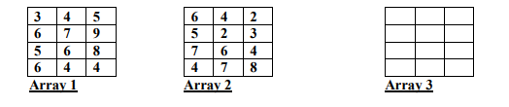

**SOLUTION:**

int r1, c1, r2, c2, i, j, z, sum = 0;

Console.Write("Number of rows in first matrix : ");

r1 = int.Parse(Console.ReadLine());

Console.Write("Number of columns in first matrix : ");

c1 = int.Parse(Console.ReadLine());

int[,] m1 = new int[r1, c1];

Console.WriteLine("--------------------------------");

Console.Write(" first matrix : \n");

for (i = 0; i < r1; i++)

{

for (j = 0; j < c1; j++)

{

Console.Write("Matrix 1 [{0} {1}]: ", i , j );

m1[i, j] = int.Parse(Console.ReadLine());

}

}

Console.WriteLine("--------------------------------");

Console.Write("Number of rows of second matrix : ");

r2 = int.Parse(Console.ReadLine());

Console.Write("Number of columns of second matrix : ");

c2 = int.Parse(Console.ReadLine());

int[,] m2 = new int[r2, c2];

Console.WriteLine(" second matrix : \n");

for (i = 0; i < r2; i++)

{

for (j = 0; j < c2; j++)

{

Console.Write("Matrix 2 [{0} {1}]: ", i, j);

m2[i, j] = int.Parse(Console.ReadLine());

}

}Console.Clear();

Console.WriteLine("--------------------------------");

Console.WriteLine("Matrix 1 \n");

for (i = 0; i < r1; i++)

{

for ( j = 0; j < c1; j++)

{

Console.Write(m1[i,j]+"\t");

}

Console.WriteLine();

}

Console.WriteLine("\nMatrix 2 \n");

for (i = 0; i < r1; i++)

{

for ( j = 0; j < c1; j++)

{

Console.Write(m2[i,j]+"\t");

}

Console.WriteLine();

}

if (c1 != r2)

{

Console.WriteLine("\n--------------------------------------");

Console.WriteLine("\nMultiplication not possible");

Console.WriteLine("\n--------------------------------------");

}

else

{

int[,] arr3 = new int[r1, c2];

for (i = 0; i < r1; i++)

{

for (j = 0; j < c2; j++)

{

for (z = 0; z < r2; z++)

{

sum = sum + m1[i, z] * m2[z, j];

}

arr3[i, j] = sum;

sum = 0;

}

}

Console.WriteLine("Multiplication : ");

Console.WriteLine("--------------------------------");

for (i = 0; i < r1; i++)

{

for (j = 0; j < c2; j++)

{

Console.Write("{0}\t", arr3[i, j]);

}

Console.Write("\n");

}

Console.WriteLine("--------------------------------");

}

**OUTPUT:** 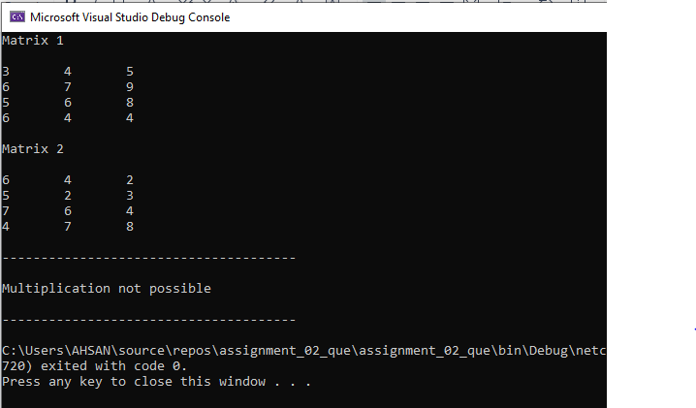

1. Write a program that will generate the monthly installment and total amount to be paid of personal loan where the insurance is 2% and mark up is 18% per year, initial processing fee is 3%.

**SOLUTION:**

int time;

double amount,insurance,fee,installment;

Console.Write("Enter amount of loan: ");

amount = double.Parse(Console.ReadLine());

Console.Write("\nEnter time duration in years: ");

time = int.Parse(Console.ReadLine());

// initial processing fee is 3%

fee = amount * 3;

fee = fee / 100;

Console.WriteLine("\nInitial processing Fee: {0:0.00}",fee);

// insurance is 2% of loan

insurance = amount * 2;

insurance = insurance / 100;

Console.WriteLine("\nInsurance of loan: {0:0.00}", insurance);

// markup is 18% (per year)

for (int i = 0; i < time; i++)

{

amount =amount+ (amount * 0.18);

}

// require installment per month so time x by month in 1 year

installment = amount / (time * 12);

Console.WriteLine("\n-------------------------------------------------");

Console.WriteLine("\nTotal Amount After Process: {0:0.00}", amount);

Console.WriteLine("\nMonthly Installment of Total Amount: {0:0.00}\n", installment);

Console.WriteLine("-------------------------------------------------");

**OUTPUT:**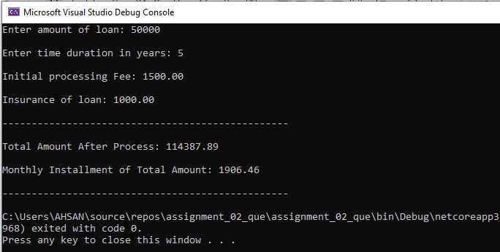

1. By using array and method, calculate the total weekly expense of Bahria University. The overall expenses are further categories as Generator’s Diesel Expense, Entertainment Expense and Maintenance Expense. Also determine the maximum, minimum and average expense in each category.

**SOLUTION:**

double t_sum = 0,sum;

int n;

Console.Write("Enter no of days: ");

n = int.Parse(Console.ReadLine());

int[] diesel = new int[n];

int[] entertainment = new int[n];

int[] maintainance = new int[n];

Console.WriteLine("\ncalculate the Weekly expense of Bahria University-----<<<<<<<\n");

for (int i = 0; i < n; i++)

{

Console.Write("enter the generator diesel expense of day {0}: ",i+1 );

diesel[i] = int.Parse(Console.ReadLine());

Console.Write("enter the entertainment expense of day {0}: ",i+1 );

entertainment[i] = int.Parse(Console.ReadLine());

Console.Write("enter the maintenance expense of day {0}: ",i+1 );

maintainance[i] = int.Parse(Console.ReadLine());

sum = diesel[i] + entertainment[i] + maintainance[i];

t_sum += sum;

}

Console.WriteLine("\nMaximum Minimum and Average Expense of Generator Diesel\n ");

Max(diesel);

Min(diesel);

Avg(diesel);

Console.WriteLine("\nMaximum Minimum and Average Expense of Entertainment\n ");

Max(entertainment);

Min(entertainment);

Avg(entertainment);

Console.WriteLine("\nMaximum Minimum and Average Expense of Maintenance\n ");

Max(maintainance);

Min(maintainance);

Avg(maintainance);

Console.WriteLine("\n----------------------------------------------------------------");

Console.WriteLine("\ntotal weekly expense of bahria university = {0}",t_sum);

Console.WriteLine("\n----------------------------------------------------------------");

}

public static void Avg(int[] arr)

{

int avg = 0;

double average = 0;

for (int i = 0; i < arr.Length; i++)

{

avg = avg + arr[i];

average = avg / arr.Length;

}

Console.WriteLine("The Average is: " + average);

}

public static void Max(int[] arr)

{

int max = 0;

for (int i = 0; i < arr.Length; i++)

{

if (i == 0)

{

max = arr[i];

}

if (arr[i] > max)

{

max = arr[i];

}

}

Console.WriteLine("The Maximum value is: " + max);

}

public static void Min(int[] arr)

{

int min = 0;

for (int i = 0; i < arr.Length; i++)

{

if (i == 0)

{

min = arr[i];

}

if (arr[i] < min)

{

min = arr[i];

}

}

Console.WriteLine("The Minimum value is: " + min);

}

**OUTPUT:**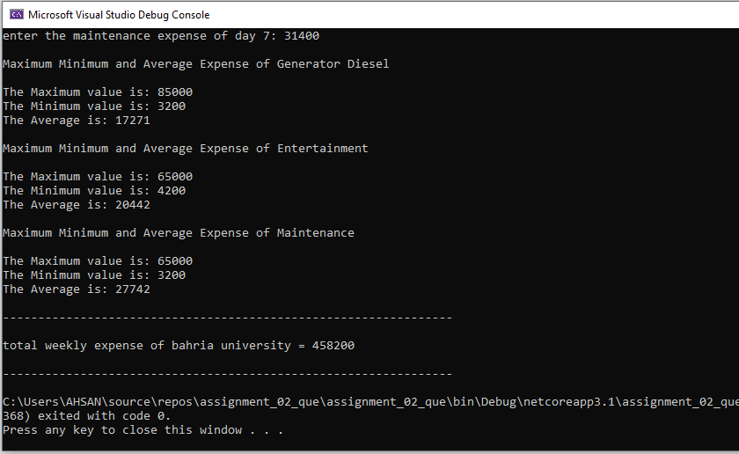

1. National Defense Finance Corporation, Pakistan has started saving schemes where they are offering two options, one with 5 years fixed deposit where the initial interest rate is 8% and is increasing 2 percent each year. In second option, client will get monthly interest amount with 8.5% per year. Write a program that will calculate the total amount after 5 years for option one and monthly amount in option 2 for the provided user input amount.

**SOLUTION:**

Console.WriteLine("\n National Defense Finance Corporation,--> saving scheme\n");

Console.WriteLine(" 1) 5 years fixed deposit");

Console.WriteLine(" 2) get monthly interest amount with 8.5%");

Console.Write("\n Which scheme do you want to get (1) & (2) : ");

int res = int.Parse(Console.ReadLine());

Console.Write("\nEnter your amount: ");

double amount = double.Parse(Console.ReadLine());

switch (res)

{

case 1:

int a = 8;

for (int i = 0; i < 5; i++)

{

double interest = amount * a;

interest = interest / 100;

double f_amount = amount + interest;

a = a + 2;

amount = f_amount;

}

Console.WriteLine("\nFinal Amount after interest of 5 years: {0:0.00}", amount);

break;

case 2:

// 8.5% interest

Console.Write("enter duration of year: ");

int n = int.Parse(Console.ReadLine());

double sub = amount * 8.5;

sub = sub / 100;

double m_int = n * sub;

double n_int = m_int / 12; // for monthly interest----->interest profit divide by 12

Console.WriteLine("\nmonthly interest {0}:",n_int);

double final_amo = amount + sub;

Console.WriteLine("\nAfter 5 year 8.5% interest of amount profit = {0}",m_int);

break;

default:

Console.WriteLine("\n >>>>>------- Wrong entry -------<<<<<");

break;

}

**OUTPUT:**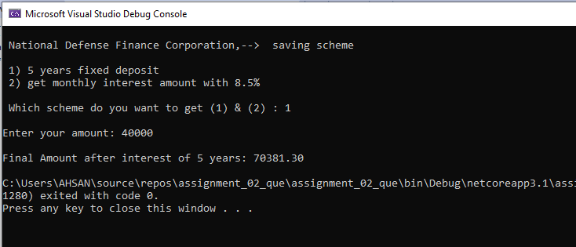

1. write a program that will generate the following output

Chapter 1 Section 1.1 Section 1.2 Section 1.3 Section 1.4 Section 1.5

Chapter 2 Section 2.1 Section 2.2 Section 2.3 Section 2.4 Section 2.5

Chapter 3 Section 3.1 Section 3.2 Section 3.3 Section 3.4 Section 3.5

**SOLUTION:**

Console.WriteLine("enter no of chapters: ");

int c = int.Parse(Console.ReadLine());

Console.WriteLine("enter no of sections: ");

int s = int.Parse(Console.ReadLine());

Console.Clear();

Console.WriteLine("\n\n");

for (int i = 1; i <= c; i++)

{

Console.WriteLine("Chapter {0}",i);

for (int j = 1; j <= s; j++)

{

if (i==1)

{

Console.WriteLine("\t\tSection {1}.{0}",j,i);

}

else if (i==2)

{

Console.WriteLine("\t\tSection {1}.{0}",j,i);

}

else if (i==3)

{

Console.WriteLine("\t\tSection {1}.{0}",j,i);

}

}

}

**OUTPUT:** 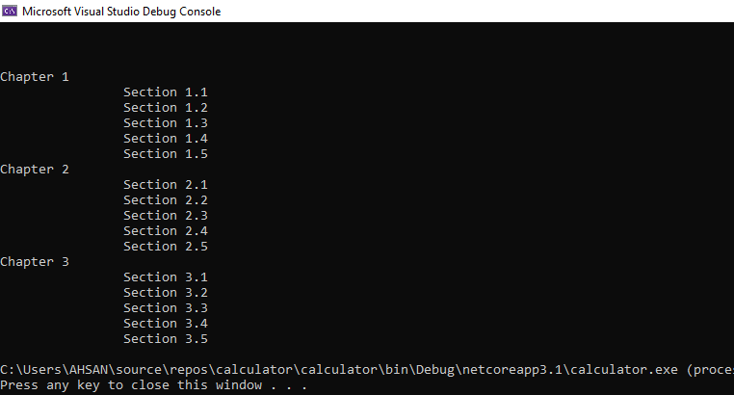

THE END

AHSAN SAJJAD